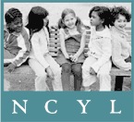February 21, 2013

Governor Jerry Brown

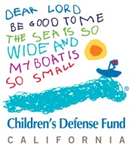State Capitol

Sacramento, CA 95814

**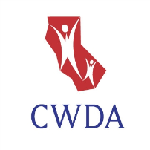OPPOSITION** TO ELIMINATION OF FOSTER YOUTH SERVICES **(line item: 6110-119-0001)** AND **SUPPORT** FOR **MEANINGFUL** INCLUSION IN THE NEW FUNDING FORMULA

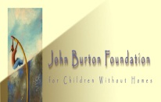 The State of California has a unique responsibility to children in foster care. In removing them from their families and homes, the state assumes the responsibilities normally vested in a parent. Unlike any other population of children, the State of California is wholly responsible for their well-being and educational success. In recognition of this responsibility, and in response to the tragically poor educational outcomes of children and youth in foster care, California must prioritize these students.

**THE FOSTER YOUTH SERVICES PROGRAM (FYS) MUST BE PRESERVED**

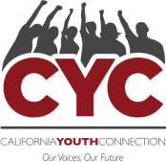

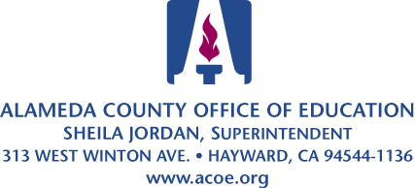As documented in numerous reports, California’s FYS program has improved the educational outcomes of foster children and serves as a model for other states. The COEs provide the types of educational management, advocacy, transition planning and coordination normally provided by a parent. Foster children are a marginalized, largely invisible, population of students. The loss of FYS will leave tens of thousands of California foster children without anyone assuming the role of parent and supporting their educational success.

http://www.portical.org/images/sccoe_logo_new.gif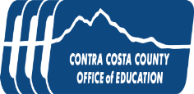There are also substantial costs associated with eliminating the FYS program. State FYS funds bring California millions of dollars of otherwise unavailable federal funds by serving as a Title IV-E match. Federal laws such as the Fostering Connections Act require child welfare agencies to monitor and track the educational progress of foster children, while recent changes to FERPA further emphasize the need for education and child welfare agencies to work collaboratively to improve the educational outcomes of foster children. The costs of complying with state and federal mandates will increase if, instead of coordinating education services with one county-level education agency, agencies have to work with up to 80 school districts.

http://www.portical.org/images/sccoe_logo_new.gifhttp://www.portical.org/images/sccoe_logo_new.gif

**LOCAL CONTROL FUNDING FORMULAS MUST ACTUALLY BENEFIT FOSTER YOUTH**

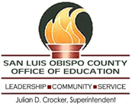

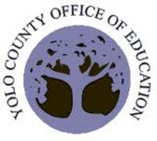We commend the Governor for recognizing that students in foster care have unique educational needs that require school districts to provide unique educational services. To succeed in school, many children in foster care must overcome trauma suffered as a result of abuse or neglect, removal from home, placement changes, and frequent school changes which often result in gaps in academic learning.

Unfortunately for foster children, under the Governor’s current budget proposal:

1. FC_logoforWrd_F8The vast majority of LEAs do not know which of their students are in foster care. Those LEAs that do, depend on the FYS program for this information, which the Governor’s budget eliminates.
2. Since every foster child is categorically eligible for the FRLMP, districts will not receive a single additional penny as a result of a student being in foster care.
3. LEAs are required to track and report the educational outcomes of EL students and FRLMP students, but are not required to track and report the educational outcomes of students in foster care.
4. Under existing law, LEAs are held accountable for the academic performance of EL and FRLMP students. LEAs are not held accountable for the academic performance of students in foster care.

For the reasons listed in this letter, the State should preserve California’s Foster Youth Services program (6110-119-0001) and amend the local control funding formula to ensure that students in foster care are meaningfully included.

Sincerely,

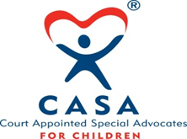

Jesse Hahnel

Director, Foster Youth Education Initiative

National Center for Youth Law

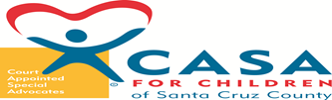

Jamila Iris Edwards

Northern California Director

Children’s Defense Fund

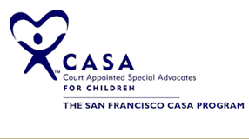Frank J. Mecca

Executive Director

County Welfare Directors Association of California (CWDA)

[](http://fosteryouthalliance.org/)

Amy Lemley

Policy Director

John Burton Foundation

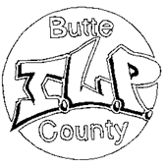Crystal O'Grady

Policy Coordinator

California Youth Connection

Sheila Jordan

Superintendent

Alameda County Superintendent of Schools

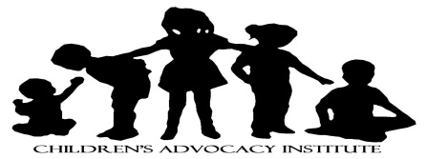Alameda County Office of Education

Catherine Giacalone

Youth Development Services Manager

Contra Costa County Office of Education



Michael Watkins

Superintendent of Schools

Santa Cruz County Office of Education

Jessica Thomas Senior Program [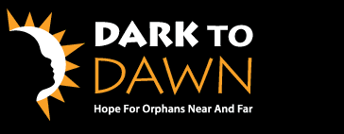](http://www.darktodawn.org/)Coordinator

San Luis Obispo County Office of Education



Jorge Ayala

Superintendent

Yolo County Office of Education

Eleanor Averitt

Program Assistant, Foster Youth Service

Elk Grove Unified School District

James C. Wogan, LCSW, PPSC

Administrator, School Linked Services

Mt. Diablo Unified School District

Foster Youth Services

Murry Schekman

Assistant Superintendent

Pajaro Valley Unified School District

Carol Ann Franklin, Ed.D. Professor Emerita

Partnership for Youth in Foster Care, Director

San Bernardino County Superintendent of Schools

Foster Youth Services

University of Redlands, School of Ed.

Kara Hunter

Executive Director

Court Appointed Special Advocates of San Bernardino County

Cynthia Druley

Executive Director

Court Appointed Special Advocates of Santa Cruz County

Jeff Perry

Educational Advocacy Coordinator

Court Appointed Special Advocates of San Francisco

Reed Connell

Executive Director

Alameda County Foster Youth Alliance



Tami Thompson

Butte County ILP Coordinator

Butte ILP County

Tracy Tousley, MA   
Executive Director / Founder

California Foster Families, Inc.

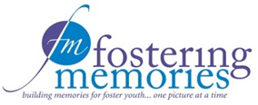Melanie Delgado

Staff Attorney

Children’s Advocacy Institute

Todd Heie

Chief Probation Officer

County of Siskiyou Probation Department

Joy Biddle

Executive Director

Creative Alternatives, Inc.



John Franklin

Director, Foster Care Ministry

Dawn to Dark

Roger Chan

Executive Director

East Bay Children’s Law Offices

Lisa L. Russell, M.A.

Executive Director

Educational Tutorial Services

Tiffany McGee

Social Worker

Environmental Alternatives

Laurie Campbell

Executive Director

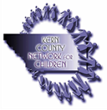Fostering Memories

Anne Ratto

Associate Dean, EOPS/CalWORKs

Gavilan College

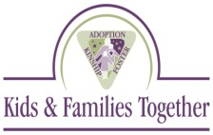

Rhonda Leiva

Assistant Director

Guardian Scholars at San Jose State University

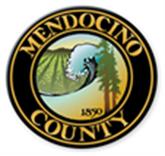

Richard Puente

Program Coordinator

Healthy Start Program

Joe Costa

CEO

Hillsides

Tom Corson

Executive Director

Kern County Network for Children

David Friedlander

President/CEO

Kids & Families Together

Bryan Lowery

Assistant Director

Mendocino County Health and Human Services Agency (HHSA)

Ralph Ward

Executive Director

Northern California Youth and Family Programs

Cal Winslow

CEO

Orangewood Children’s Foundation

Steve Duran

Director of Programs

Peacock Acres, Inc.

Tonya L. Torosian, MSW, CFRE

Chief Executive Officer

Promises2Kids

Martha Matthews

Directing Attorney, Children's Rights Project

Public Counsel Law Center

Camille Schraeder

Executive Director

Redwood Children’s Services, Inc.

Pamela Hansen, LCSW

Director of Program Development

San Diego Center for Children

Matt Martin

Executive Director

Social Advocates for Youth

James B. Pace, Ph.D.

Executive Director

Starshine Treatment Center

Patricia L. Boles

Executive Director

Straight From The Heart, Inc.

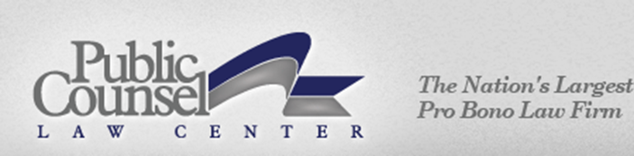

Pam Dyer

Executive Director

Sylvan Learning Center

Lisa Castetter

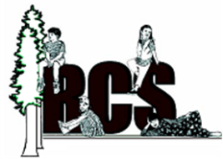Founder and CEO

Teen Leadership Foundation

Sharon M. Lawrence

President/CEO

Voices for Children, Inc.

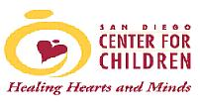Also including the following organizations as well as hundreds of California voters:

Alameda County Foster Youth Alliance

Alameda County Office of Education

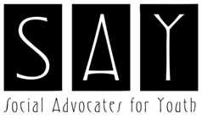Butte County ILP

California Foster Families, Inc.

California Youth Connection

CASA of San Bernardino County

CASA of Santa Cruz County

CASA of San Francisco County

Children’s Defense Fund

Child Welfare Directors Association of California (CWDA)

Children’s Advocacy Institute

Contra Costa County Office of Education

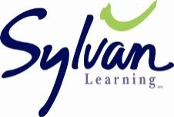County of Siskiyou Probation Department

Creative Alternatives, Inc.

Dark to Dawn

East Bay Children’s Law Offices

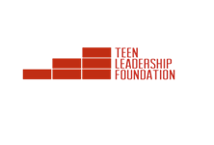Educational tutorial Services

Elk Grove SUD

Environmental Alternatives

Fostering Memories

Gavilan College

Guardian Scholars at San Jose State University

Healthy Start Program

Hillsides

John Burton Foundation

Kern County Network for Children

Kids & Families Together

Mendocino County H.H.S.A.

Mt. Diablo USD Foster Youth Services

National Center for Youth Law

Northern California Youth and Family Programs

Orangewood Children’s Foundation

Pajaro Valley USD

Peacock Acres, Inc.

Promises2Kids

Public Counsel Law Center

Redwood Children’s Services, Inc.

San Bernardino County Superintendent of Schools FYS University of Redlands

San Diego Center for Children

San Luis Obispo County Office of Education

Santa Cruz County Office of Education

Social Advocates for Youth

Starshine Treatment Center

Straight From The Heart, Inc.

Sylvan Learning Center

Teen Leadership Foundation

Voices for Children, Inc.

Yolo County Office of Education